

Course Name: Information Science and Engineering
Title: Existing Online Food Delivery System
Student Name: Ashley Lewis
USN: NNM24IS043
Semester &Section:4th Sem A
Department: Information Science and Engineering
Institution Name: NMAMIT Institute of Technology
Academic Year:2026
Faculty Name: Dr. Jason Elroy Martis
Date of Submission:12-02-2026
Abstract
Online food delivery systems have made the life of people much easier, we can order the food from our home, workplace or anywhere. These food delivery systems have put together different restaurants and have connected delivery partners through online platforms. This Case study helps us to know better about the existing food delivery systems such as Swiggy and Zomato, and understand how the system functions, their challenges. The case study mainly focuses on how these system work with customer interaction, order process, payment process and delivery process. We also look into some basic information about their mobile applications, databases and web services. We will also look into the, system’s growth, customer’s opinion about using the app, its security and its performance. We will look into this case study from a software engineering view and also make models based on this system.
GitHub Repository Link

Introduction
Food delivery systems are one of the most used technology at the current generation,because of common use of smartphones and good internet availability.Customers scroll through multiple restaurants and their menu ,place orders,make online transaction and receive the food at their given location without making much effort.As software engineering student ,according to my view food delivery applications are very huge systems which manages a huge data and has many stakeholders.
In this case study we will study the Software Development Life Cycle(SDLC) of existing food delivery application to know whether the system meets the expectations of the customer or not ,it includes time and cost too.
Here we will be comparing three main software process models that are-Waterfall Model,Increment Development Model and Spiral Model.

Problem Statement
The increasing demand for online food delivery systems has caused many challenges too,like customer’s views on the system,the application’s ability to grow.These systems must be also ready to deal with problems like order cancellation or delay,sometimes delivery might go wrong,the system might crash due to some server issue or overload and security related issues too.The problem we look into the case study is to understand how the existing food delivery systems handle these issues and problems and also look into areas where they need to improve.
The first thing we consider over here is to look into the order of the lifecycle,and understand the customer and restaurant connections and also know some basic details about the backend process that is required in payment and delivery system.

System Description
The food delivery systems use client server design.The client part contains the applications that are available r the customers,restaurants and delivery partners.The server part will look into data related things, business information and allows communication between restaurants ,delivery partners and customers.
The system starts its work whn a customer places an order from the application.The order detail is sent to the server,it checks the restaurant availability and verifies the order and sends the order details to the restaurant and it also assigns the nearest delivery partner to deliver the order to the customer .It handles the online payment making sure its safe and causes no loss to the customer .Once the order is handed to the delivery partner live order tracking will be also provided to the customer until the customer receives the order.[2]

Tools and Technologies used
- Documentation tool:Microsoft Word
- Diagram:Draw.io
- Repository hosting:Github

Analysis and Comparison
- Waterfall Model
The Waterfall Model it maintains a step by step method where the previous step must be completed before going to the next step,like all the required information collection,designing the system,implementing it ,testing,running the system and its maintainance.For the food delivery system this model is not suitable because these systems need to be regularly updated and needs some changes in the way they function,like the customer login details,restaurant browsing,placing orders, payment process and live tracking the order.But in the waterfall model all the conditions and requirements should be fixed at the starts itself ,which makes its difficult to make changes later or add new features to the system like latest payment updates or improved tracking .And non functional requirements like the security and its ability to grow they are also difficult to improve later.This model is said to be weak in managing the risks that may occur in the system,because risks are usually detected later ,usually during testing and making any changes at the end creates even more problems.At first the cost seems to manageable but later as the changes increases the cost increase a lot .Because food delivery applications should be able to add and make changes easily,so the waterfall model is overall not good for developing food delivery apllications.[3]
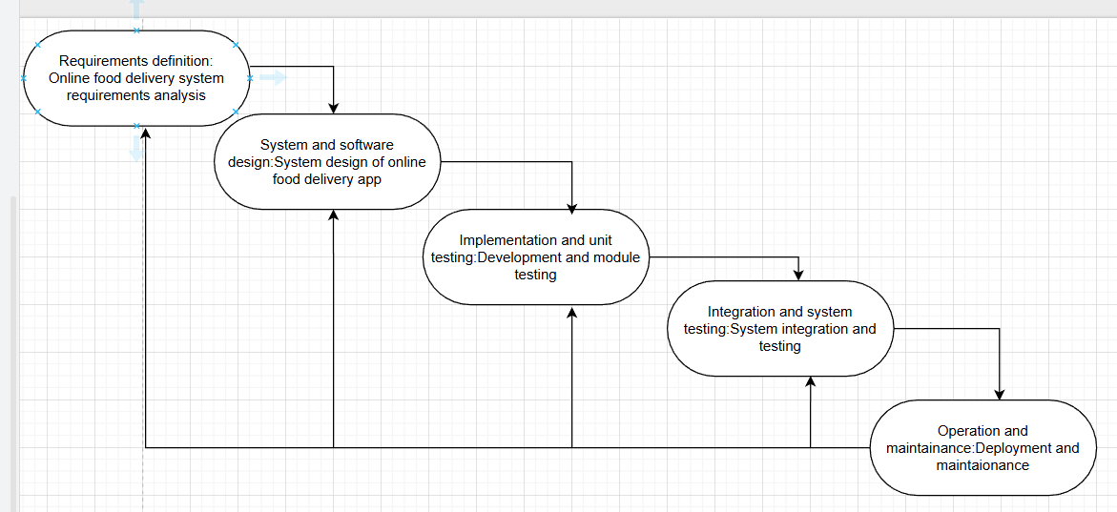

- Incremental Development Model
The Incremental Development Model creates a system step by step ,it adds small parts one by one,and every time a new part is added ,new functions are also added with it.This model is good for a food delivery system because its main feature like customer login and restaurant listing it can be created first ,later the other remaining features can be added part by part,like order placement,payment process and live tracking .Here once each part is developed it gets tested before going to the next part.This makes sure that everything is fine.Non functional requirements the running speed,and how easily the customers can use this system can be improved slowly with each added part and also as more users start using it the system updates itself.This model can handle risk much better than the waterfall model because it uses the customers feedback at the beginning itself to improve ,any changes required can be made later without affecting the whole system.This saves time and features are added quikly too,overall the cost is not high too compared to other models,ythis makes it great for food delivery systems. [3]
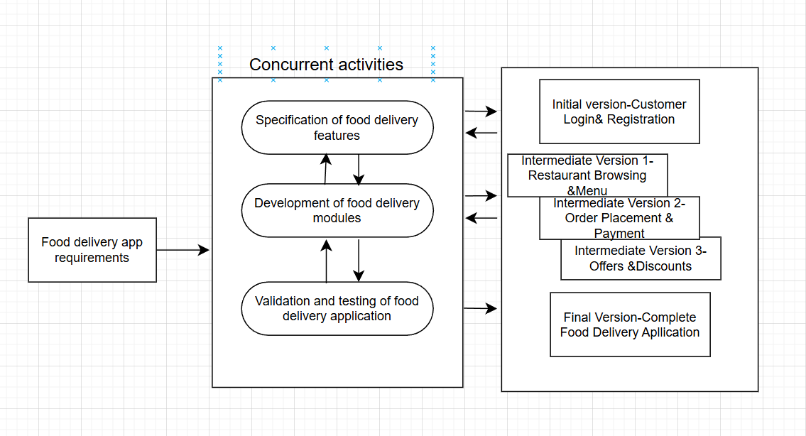

- Spiral Model Analysis
The Spiral Model works in loops ,so its great for handling the risks that may occur.In every loop it checks for any problems that may occur and also corrects it early .It is good for both functional and non-functional requirements.Its used in food delivery systems when the application requires some complex things to include ,like security of payment process and when it needs to handle many users at the same time.
It allows improvement ,so the changes can be made easily without any difficulty in every loop.Sometimes risks like payment security ,system might crash due to overload and data security and privacy issues can be handled easily by this model.It helps us to get great results,but its also costly and time consuming.It needs good professionals,so its great for big and high risk projects .[3]

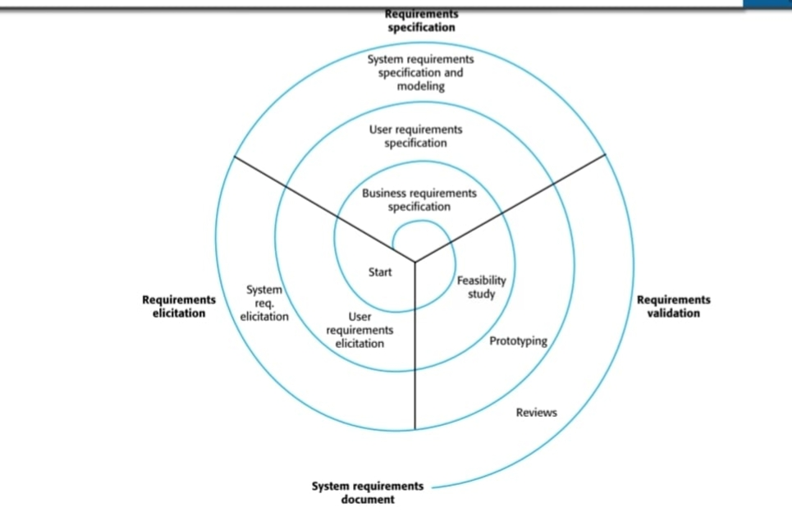

Requirement Document
- Functional Requirements
- This application should help customer to login safely.
- Different restaurants along with their menu should be available online in the application.
- Customers must be able to place their food orders online.
- The application must be good for online payments and cash on delivery even during busy hours.
- It must allow tracking the order.
- Customers should be allowed to rate and review the food and the restaurants.[2]

- Non Functional Requirements
- The application should be fast in order placement.
- Customer details and payment data must be safely used.
- The food delivery application should be available anytime even during busy hours.
- The system should be suitable to support large number of users.[2]
Requirements Validation Strategy
Requirements are checked by asking the feedback with the stakeholders,whether they match the expectations of the user.After each change or newly added function in each added part is tested immediately.The customer feedback is taken from the previous version of the system so that the future systems can be improved.

Challenges in Requirements Engineering
- User needs get changed regularly due to new trends.
- Its hard to fullfill all user expectations at the beginning itself.
- Have to look after the non functional needs like security and how it works.
- Have to balance the cost and time too.[1]

Result and Analysis
According to the information that we have collected and presented in the case study ,we can say that its safe to use Incremental Development Model for food delivery systems.Because food delivery systems need regular changes and have to add some new features in middle ,which can be easily done by using this model.It is also cost and time efficient compared to other models.

Conclusion
In conclusion,online food delivery systems have made our life much easier.We can order food from anywhere by just staying at our home.For these systems to work there is a application that works behind it which manages orders,payments,restaurants and connect to delivery partners.
In this case study we get to know how the systems work and the problems that they face,might be regarding order delays,order cancellation,refund related ,payment issues and server crashes due to more load.We also compared 3 different software models to check which one is better for food delivery systems.
From our case study we got to know that Incremental Development Model is the bets choice for food delivery apps because they need regular changes and new features.In this model we can make any changes or add new features easily.Any changes or features are added step by step here.
Overall,food delivery systems are of great use but it needs to handled and secured well.
Reference
[1] “7 major challenges faced by Food Delivery Apps,” Phontinent Technologies - Solutions for Demanding Business, https://www.phontinent.com/7-major-challenges-faced-by-food-delivery-apps/ (accessed Feb. 11, 2026).
[2] GeeksforGeeks, “Food Delivery Application Project in Software Development,” GeeksforGeeks, https://www.geeksforgeeks.org/software-engineering/food-delivery-application-project-in-software-development/ (accessed Feb. 11, 2026).
[3] GeeksforGeeks, “Software development life cycle (SDLC),” GeeksforGeeks, https://www.geeksforgeeks.org/software-engineering/software-development-life-cycle-sdlc/ (accessed Feb. 11, 2026).

Declaration of Academic Integrity
I hereby declare that this assignment is my original work and has not been copied or plagiarized from any source.All references and resources used have been properly cited.Any ambiguities will lead to forfeiting my marks.
Student Signature: 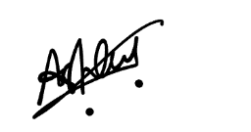
Date:12-02-2026

